Greenpower Sample Teacher’s Guide to Getting Started

Short implementation plan for accelerating Greenpower adoption
The goal of this teacher’s guide and plan is for educators to use it as a guideline for helping students develop their own Greenpower implementation plan. Below is an example of activities over a 6-month period. Depending on race day and program start, this chart will be adjusted. This chart is just one example of possible tasks and the timeframe in which they could occur.
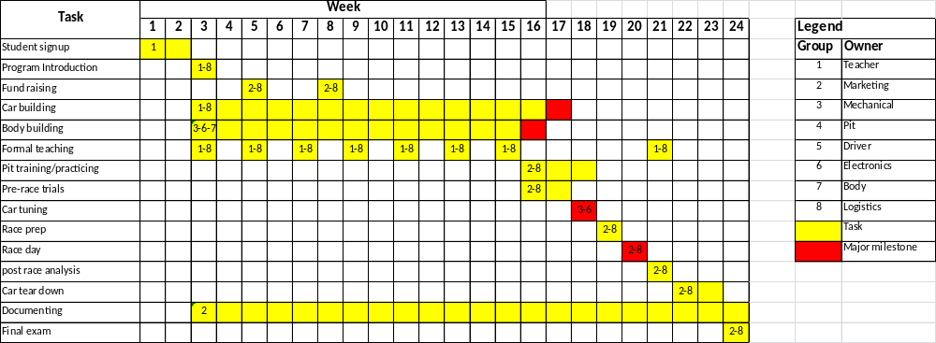

Task descriptions
- Building a team
  - Recommended team size is approximately 14 students
  - Raise Awareness and Recruit Team
    - Email parents
    - Announce in classes (STEM, Math, and so on)
    - Display recruitment poster (sample provided in packet)
  - Ideally looking for motivated students who are self-starters
  - Try to have recruitment done by week two of school, if you’re starting the program in the new school year
  - Make sure you have a dedicated room or dedicated space to build the car
  - Have students fill out a Greenpower Application Form (sample provided in packet)
  - Conduct interviews; stress the time commitment needed for the project
  - Select a time
- Kicking off Greenpower at your school
  - Provide an introduction to Greenpower (slides, YouTube videos, and so on)
  - Get the students involved in selecting a team name and a name for the car
  - Let the students decide what team positions are needed (driver, mechanical, electrical, pit, marketing, logistics)
  - Walk through the assembly instructions, if building a kit car
  - Begin team uniform selection
  - Teach basic and simple project management (let students create a Gantt chart and assign owners)
  - Make sure students become familiar with the Greenpower Rules and Regulations (on the Greenpower web site)
  - Let the students unbox the car and start organizing what to build
- Fundraising
  - Per Gantt chart, have students think of fund-raising ideas
  - Plan what the money is to be used for (pay for car, tools, equipment, uniforms, safety gear, race logistics) students
  - Decide how many fund-raising events should be done
  - Define targets, projections
  - Have students create any content and develop the sales pitch
  - Practice sales pitch
  - Work on the logistics (when, where, and so on)
  - Look at what NASCAR and other professionals do
    - Sell ad space on car/uniform
    - Autographed photos
    - Recruit major sponsor
  - Teaching points: How to sell and market
- Car building (work through Siemens Solid Edge materials on Mechanical Systems and FEA)
  - Assign who will work:
    - Frame
    - Body
    - Suspension
    - Electrical
    - Steering
  - Assign who will ensure rules and regulations are implemented
  - Teaching points:
    - How to manage a project and keep tasks on schedule
    - Measuring tools, micrometers, timers, scales
    - Basics of:
      - Tools, names, types, purposes
      - Structures (simple static loading)
      - Electricity (basic ohms law and current flow)
      - Aerodynamics (compare dolphins vs school buses)
      - Fasteners and when to use what (tape, bolting, gluing, welding)
- Body building (work through Siemens Solid Edge materials on Surface Modeling)
  - What is the basic design
  - What materials should be considered and eventually used
  - How can the body get built
  - When can the body be built
  - Who will ensure rules are kept
  - Teaching points:
    - How to make conceptual drawings
    - How to manufacture (including 3D printing)
    - How to solicit bids for getting something made
- Pit crew training
  - What needs to be done (per the rules)
  - What happens if there are minor issues (flat tire)
  - Contingency plan for major issues (burned out motor)
  - How to change a tire
  - How to change a battery
  - How to align suspension if applicable (in case car gets bumped)
  - How to fix body that may be falling off
  - Teaching points
    - How to record times, how to plot times to predict distance
    - How to work as a team
- Tuning
  - How to set the correct tire pressure
  - How to align the suspension if applicable
  - How to level the car
  - Teaching points
    - How to evaluate data and refine
- Pre-race trials
  - Use this to drive first completion milestone
  - Get a baseline of car performance (nothing to compare to, except additional trials)
  - Try modifying parameters during tuning and test against the baseline
  - Plot lap vs time for each battery—try to determine the strongest battery
  - Teaching points
    - How to measure and evaluate equipment
- Driver selection
  - Everyone should have a chance, but perhaps order of driver based on some simple tests
    - Fastest slalom time without hitting cones
    - Can get from start to finish without hitting the finish cone
    - Can drive the straightest line in less time
  - Teaching points
    - Learn how to be fair and develop a fair test
- Race day preparation
  - Set expectations -- winning isn’t everything. Practice good sportsmanship.
  - Make sure race day assignments are made in detail and understood.
  - Determine what back-up equipment to bring.
  - What tools to bring
    - Battery charger
    - Bring first aid kit
    - Bring water/snacks
    - Bring small tent for home station
  - Inspect car for rule compliance (at race day, car will be scrutineered to make sure it meets all safely requirements
  - Determine how the car will be transported to the event
  - Backup plans for flat tires
  - Preparing for potential media interviews, signing parties, general PR, how to sell yourself
  - Teaching points
    - How to win
    - How to lose
    - How to follow set rules and regulation
    - How to talk to media/parents/competitors
- Race day
  - Sign in
  - Set up pit area
  - Minimize theft
  - Review student safety
  - Prep car
  - Record lap times, (lap vs time to predict distance based on pre-trials)
  - Give pep talks
  - Determine what to do if car totally fails
  - Decide how to fill the gap if the driver/pit/anyone is a no-show
  - Discuss how to prevent competition industrial espionage
  - Teaching points
    - How to stay focused
    - How to adapt to changing circumstances
- Post-race
  - What worked, what didn’t work
  - What were the questions from the media
  - Documenting success/fail for next year to learn from
  - How did race results compare against trials
  - Any car wear
  - Teaching points
    - How to evaluate success and failures
  - Fix what didn’t work during race
- Tear down
  - Disassemble car (optional)
  - How to catalog and package parts so nothing gets lost
  - How to store car, tools, parts
  - Teaching points
    - How to organize parts/instructions/materials
- Documentation
  - Why should the program be documented
  - How to document for next year’s team
  - Where to post pictures, videos, tips
  - Should your school get a dedicated YouTube channel, Facebook account, Linked in account, Instagram, Kik, and so on
  - Teaching points
    - How to record history
    - How to leverage social media
    - How to show sponsors their investment was well used
    - How to lead USA in Greenpower implementation
- Final exam for students taking Greenpower as a class
  - Maybe 90% participation, 10% exam grade
  - Write a simple project plan on hosting say, a Halloween party
  - Come up with an idea on how to raise money for a science project
  - Matching (pictures -> tools, pictures -> car parts, and so on)
  - Choose the most important things for saving energy in a car
  - If a motor draws 25 amps from a 12v battery, what’s the power?
  - Compute weight of a car given all its components—add some thinking points (Mary weights 100 lbs. but drinks ½ gallon of water, and so on)
  - List three things you learned from this project

Building a Student Greenpower Team
Application deadline:
<TBD>
Application process:
- Written application must be turned in and completed by the student
- Conduct a personal interview to determine commitment level and area of interest
- Formal acceptance or rejection letters will be handed out to applicants
Who can apply:
- Any student enrolled at SCHOOL during the 2015/2017 school year.
How many students will be selected:
- Ideally, 14 students total
Team positions:
- Project manager: 1-2 students to help manage the entire project, ensure tasks are assigned and completed, plan created and executed, car built and ready for race day, and so on.
- Builders: 6-8 students who are good with building things or willing to learn. Knowledge of mechanical, electrical, and computers will be helpful.
- Drivers: 1-2 students who have a competitive spirit and can process information while quickly making adjustments; note that all participants can become drivers.
- Pit: 2-4 students who can fix things and work under pressure.
- Media / relations: 1-2 students who are good communicators, good at social media and fundraising.
Fees
- Free to students
- Students must be willing to participate and run fund-raising projects to pay for program costs
Program time and duration
- After school TIME, DAY with possible occasional Saturday participation for race preparation.
- During specific class; could be design & drafting, engineering, manufacturing, and so on.
- Note that attendance can be flexible but requires teacher approval in advance.
Program location:
- <TBD>
Students will learn:
- Engineering principles
- How to build things
- How to break down a complex problem
- How to analyze results
- How to manage a large project
- How to market a product and raise funds
- How to work with a team
- How to become a self-starter
- Soft skills
- How to win and how to lose
When is the first race?
- Check with Greenpower (www.greenpowerusa.net) for dates

